Last Update: July 31, 2017



Concur App Center - Client FAQ

The [Concur App Center](https://www.concur.com/en-us/app-center) provides partner apps and services that extend the value of your Concur solution. These apps and services provide greater insights into your total spend, simplify travel and expenses, and bring travelers closer to the perfect business trip.

If you have App Center questions not covered in this document please email [AppCenterMarketing@concur.com](mailto:AppCenterMarketing@concur.com).

|  |
| --- |
| Q: What is the Concur App Center? |

The Concur App Center is a listing of applications that offer pre-built integration with Concur. The App Center is available within Concur Solutions and at www.concur.com/appcenter. There are both apps for companies and apps for individual users:

* **Enterprise Applications (formerly Apps for My Business):** Clients can discover turnkey business solutions that seamlessly integrate with Concur. Examples include apps like Taxback international, which helps companies reclaim Value Added Tax for international travel and industry solutions from IMS to help ensure compliance with international regulations for the Life Sciences industry.
* **User Connections (Apps for Me):** Individual users can link user connection apps to their own Concur account. Examples include Uber, Lyft, and a variety of apps to help users manage their expenses more efficiently. Additionally, users with TripLink will be able to link their accounts with travel suppliers like IHG or Starwood so reservations made on their websites flow automatically into Concur.

The Concur App Center helps companies improve spend management and compliance while making travel and expensing easier for users. Pre-built integrations allow for easy adoption and deployment.

|  |
| --- |
| Q: Will users be downloading apps in Concur? |

No, because our App Center is only about enabling the flow of data between Concur and other

tools, there is nothing to download in Concur. If they don’t already use an app,

users would need to first set up an account with that provider (and in some cases download

the provider’s app on their mobile device) and then link their accounts.

|  |
| --- |
| Q: How do I access the Concur App Center? |

The App Center is available on Concur’s public website, the “In-Product” solution and in Concur Mobile (only user apps).

* Public Website: <https://www.concur.com/en-us/app-center>
* In-Product: <https://www.concursolutions.com/>
* Concur Mobile: Download the most recent version of the app

|  |
| --- |
| Q: Who can see the Concur App Center tab? |

All Concur users and admins. All partner listings can be found in the public and “In-Product” App Center. The Concur Mobile App Center currently only displays apps in the user connections category. All Concur Standard, Professional and Premium Edition clients and users have access.

|  |
| --- |
| Q: What is a Concur App Center Developer or Partner? |

App Center Developers and Partners have a business relationship with Concur and have built apps that integrate with Travel, Expense and/or Invoice. The apps are vetted and certified before release to ensure secure integration with Concur solutions.

|  |
| --- |
| Q: How does Concur review App Center Partners and integrations? |

Each app appearing in the App Center is reviewed by Concur before clients or end users can

connect with the application. Concur reviews the application to confirm the following:

* The app requests permission to access only web services suitable for the purpose of the app (Enterprise Applications).
* For apps that request access to credit card information, Concur confirms that the app provider is PCI compliant.
* The app does not generate unacceptable volumes of requests.
* The app does not generate unacceptable levels of error messages.
* The app’s user interface generally conforms to the app provider’s documentation.

Concur ensures that the partner informs the user of the type of data they will be sharing with the partner if they connect. This provides complete transparency to the user on the data they are sharing with the partner.

|  |
| --- |
| Q: How do I know the app I’m connecting with is secure? |

Concur's platform enforces several layers of security:

* OAuth 2.0 is used to control information sharing so that an app cannot access information associated with a user or customer without approval from the user or customer.
* Secure Sockets Layer (SSL) is used to manage the security of data transmissions.
* App registration and formal certification ensures only known apps may integrate with Concur.

|  |
| --- |
| Q: What is “OAuth 2.0”? |

OAuth is an open standard for authorization. OAuth provides a method for clients to access server resources on behalf of a resource owner (such as a different client or an end-user). It also provides a process for end-users to authorize third-party access to their server resources without sharing their credentials (typically, a username and password pair), using user-agent redirections.

|  |
| --- |
| Q: There are two sections in the App Center, “user connections” and “enterprise applications”. What’s the difference? |

**User connections (formerly Apps for Me)** are end-user apps. Users can “connect” their accounts enabling relevant data to flow between the two solutions. An example would be TripIt, an app which provides a Concur Travel integration. It’s important to note that the apps displayed on this tab are based on the client’s product configuration; for example a user with Concur Travel only will not see expense related apps.

**Enterprise applications (formerly Apps for My Business)** are enterprise apps that need to be procured and activated by the appropriate Concur administrator in an organization. In the App Center, individuals can learn about the apps that are available and send an inquiry to the partner. Once you have contracted with the partner and provided Concur with a signed Letter of Authorization (provided by the partner) signifying that you authorize Concur to enable the integration the app can be enabled. There will typically be a few steps to configure the integration, depending on the application type. An example would be Taxback International, which provides an Expense integration.

|  |
| --- |
| Q: If a company is NOT a TripLink client, will they see TripLink apps? |

No, if a company does not have TripLink they will not see Concur TripLink

apps in the “user connections” section when logged in to Concur.

|  |
| --- |
| Q: What actions can a user take from the App Center? |

On each App Center Partner listing, a “Request Information” button will be available for users to click to complete an inquiry form that will be submitted directly to the App Center Partner; this is for apps in the enterprise category. User connection apps will have a “Login to connect” button requiring them to log into their Concur account to connect their account.

Users can also view brochures, videos, contact information and the partner’s website for both types of apps.

|  |
| --- |
| Q: What is different about the public website experience and the “In-Product” experience? |

In the “In-Product” experience, users will be able to view which end-user applications they have connected with (indicated with a green check box) and disable those integrations if desired.



The public website experience will not display which apps the user is connected to.

For both the “In-Product” and public website App Center, enterprise applications will only display the app listing and the option to “Request Information” with the partner.

User applications in the “in-product” App Center are also filtered by the user’s region, the Concur products their company is using (Travel, Expense, and/or Invoice), and whether or not their company has purchased TripLink.

|  |
| --- |
| Q: I’m an Administrator. What if I don’t want my users to download an app from the Concur App Center? |

Users cannot download apps directly from the Concur App Center, it’s simply a means to open a secure gateway to share relevant data between their Concur account and their account with the partner. If you have concerns about your users being able to connect with any of the user apps, you’re able to disable them following the instructions [here](https://go.concur.com/rs/013-GAX-394/images/Disabling%20Apps%20for%20Me_2015.pdf).

|  |
| --- |
| Q: I’m an Administrator. I’m not sure I want my users to see certain apps because I’m concerned that will encourage them to book out of policy – will it? |

Travel booking controls, content and search results are still defined by you. Travelers will only

see TripLink supplier listings if you have enabled the TripLink service. Admins may also disable certain user applications so that users are not able to connect their accounts via the instructions [here](https://go.concur.com/rs/013-GAX-394/images/Disabling%20Apps%20for%20Me_2015.pdf).

|  |
| --- |
| Q: Can any user connect to an enterprise application? |

No, only users with administration permissions (as defined in the [App Center Administration Guide](http://www.concurtraining.com/customers/tech_pubs/Docs/ConcurPremier/UG_Shr/Shr_UG_AppCenterAdmin.pdf)) can connect to enterprise applications.

When viewing enterprise applications as an administrator, you will see the following options:

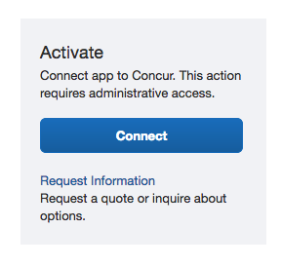

Users that do not have administration privileges will see the below and will be unable to connect.

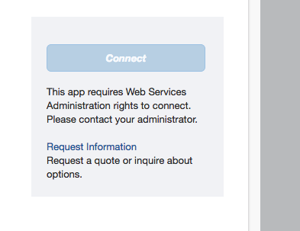

For more information on connecting to enterprise applications as an administrator, please see the [App Center Administration guide](http://www.concurtraining.com/customers/tech_pubs/Docs/ConcurPremier/UG_Shr/Shr_UG_AppCenterAdmin.pdf).

|  |
| --- |
| Q: What happens if a user clicks on “Request Information” in the Enterprise Applications section? |

If a user clicks the “Request Information” button, they will be taken to a contact form. If the form is submitted, the partner will reach out to the contact and engage with them for more

information about their app. All enterprise app integrations require an authorized

contract and Concur Administrator engagement.

|  |
| --- |
| Q: Why do I want end-users to see “Enterprise Applications”? |

By offering visibility of “Enterprise Applications” to your user-base, you may

discover that there are additional needs among your traveling community for specific

integrations with Concur Travel & Expense. For example, a sales person may have the need to

integrate Concur Travel & Expense with a CRM or ERP system. If they see a connection is available in the App Center, they can communicate that to their company for further review of the solution.

While there may be many areas of the business that determine if an app is a good fit

for their business requirements, they will always require the involvement of the Concur

Administrator to activate an application so there is no risk of an enterprise app being

enabled without the Concur Administrator’s authorization post a contract signature.

|  |
| --- |
| Q: Is there a cost for the App Center? |

Access to the App Center is free of charge. If a company chooses to connect with an enterprise app, they first have to contract with that App Center partner directly, where there may be a cost. These transactions are between you and the partner and are not facilitated within the App Center. Some of the user connection apps will have costs associated with using that partner’s service. The users can procure the service directly from the partner but again, those transactions are not facilitated within the App Center.

|  |
| --- |
| Q: Are all of the apps listed relevant to my organization? |

Not necessarily. There may be enterprise applications which are relevant only for a particular vertical industry or region. Advanced filtering and search functionality are available to enable you to easily find the apps that are most relevant.

User connection apps displayed are based on the client’s product configuration; for example a user with Concur Travel only will not see expense-related apps.

|  |
| --- |
| Q: Is the App Center available to all countries and regions? |

Yes. Regional availability will be noted in the details page of each app listing in the App

Center.



Additionally, Concur is adding regional public App Centers. So far, we have pages with specially-curated apps for [Japan](https://www.concur.co.jp/app-center), the [UK](https://www.concur.co.uk/app-centre), and [Australia](https://www.concur.com.au/app-centre), with more to come.

|  |
| --- |
| Q: What does the App Center look like? |

What you’ll see in the public and in-product [App Center](https://www.concur.com/en-us/app-center):



What you’ll see in the Mobile App Center:

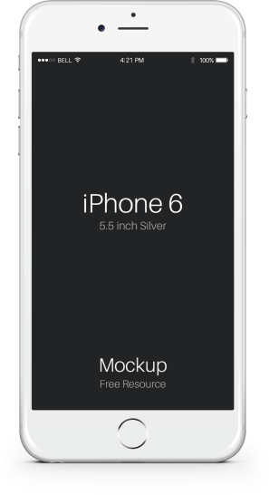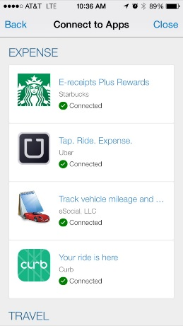

|  |
| --- |
| Q: I don’t see an application I’d like to have. Who can I talk to? |

Please email [AppCenterMarketing@concur.com](mailto:AppCenterMarketing@concur.com) with your App Center Partner recommendation.

|  |
| --- |
| Q: Who can I contact for other questions? |

If you have additional questions or would like to discuss the Concur App Center, please email [AppCenterMarketing@Concur.com](mailto:AppCenterMarketing@Concur.com).